Damanhour University

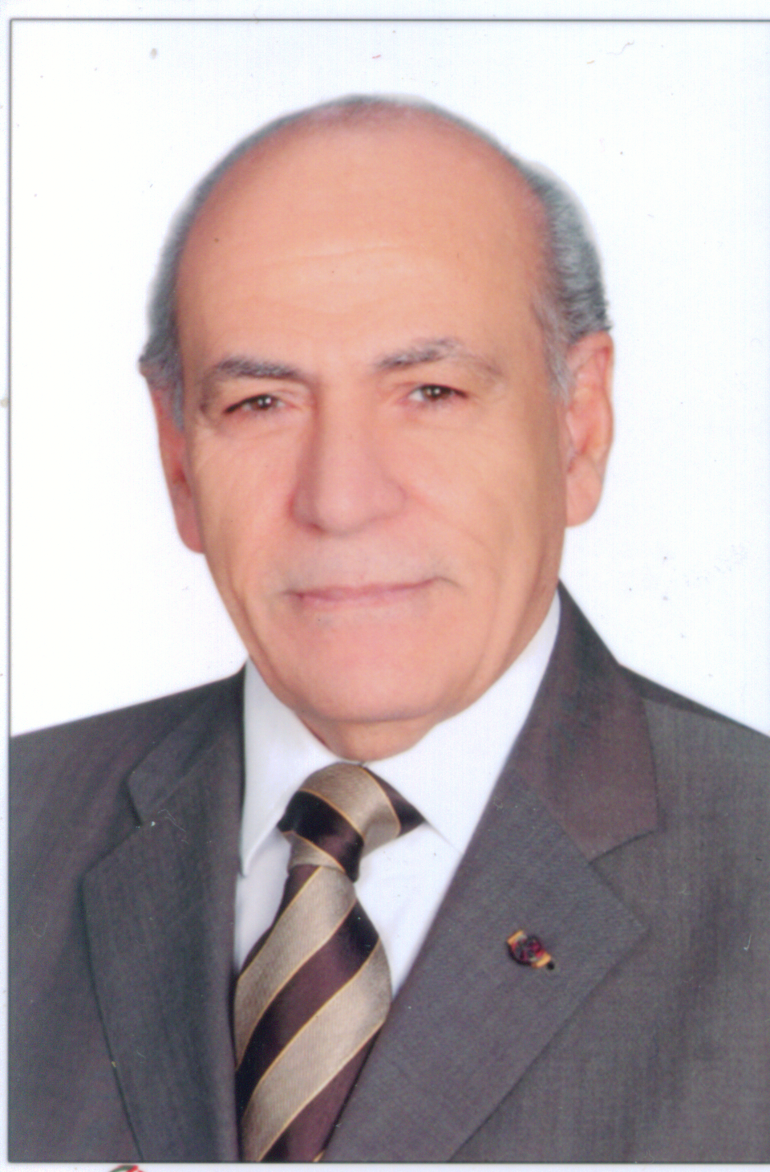

Faculty of Agriculture

CURRICULUM VITAE

Prof. Dr. Moustafa Abdellatif Abbassy

Professor of Pesticide Chemistry and Toxicology

Faculty of Agriculture ,Damanhour University , Egypt

**Name Prof. Dr . Moustafa Abdellatif Abbassy**

**Title** Prof. of Pesticide Chemistry and Toxicology from 1982 till now.

**F**ormer Dean , Fac. of Agric. Alex. Univ. , Damanhour,Egypt.

**E-mail** [maabbassy@yahoo.com](mailto:maabbassy@yahoo.com)

***Awards***

**1- First Class Medal in Arts and Sciences ( National Award from the Country**

**President ) in 1985** .

**2- The national Encouragement Award in Agricultural Sciences in 1983 .**

**3- The national Environmental Award in 1979 .**

**4- University of Alexandria Recognition Award ( Golden Medal ) in 1999** .

**5**- **Recognition Award from Univ. of Damanhour in 2012.**

**6- Recognition certificate and Golden Medal from Alexandria University in 2003.**

**External Technical Visits** :

Research Professor , **University of Maryland** , ( **1981 – 1982**), Visiting Professor , **University of Minnesota**, USA **(1993** )., Visiting Professor , **University of Hohenhium Stutgart,Germany ( 2002**)

**RESEARCH PROJECTS : (Competitive Grants): (Eight Projects in fields of pesticides and pest control.**

## ADMINSTRATION

* **President of the Permanent Committee for Promotion of Professors and Associate Professors of Plant Protection and Phytopathology, Egyptian Supreme Council Universities (2013-2015) and member in the same committee (2008-2012).**

**\* Member in the** **National Supreme Council of Environment** **from 1988-2003** **Academy of Science and Technology** , **Egypt .**

**\* Member in the** **Agricultural Pesticides Committee, from2011 till now, Ministry of Agriculture and Land Reclamation, Egypt.**.

**PUBLISHED BOOKS AND RESEARCH PAPERS : In Arabic: Ten Books (1993 – 2010) and shared in writing one chapter in each of Two Text Books (published in USA , 1984) concerning the Chemistry and Toxicity of Pesticides, Neurotoxicology and pest control .Published 136 papers in National and International Journals (1976-2013).**

# SUPERVISED AND EXAMINED : 97 MSc and PhD Thesis in the fields of Pesticide Chemistry and Toxicology and Pest Control .