Prof. Dr. Mohsen El Guindy

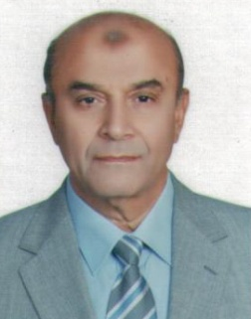

**Date of Birth:** June 10,1943

**Bachelor degree :** Faculty of Agriculture, Cairo University, 1963

**MSc:** Faculty of Agriculture, Department of Genetics, Cairo University, 1968

**phD:** Faculty of Agriculture, Department of Genetics, Cairo University, 1973

**Present Occupation**:Senior Researcher, Agricultural Research Center, Ministry of Agriculture, Dokki, Egypt

**Scientific Career:**

Published more than one hundred scientific papers in local and international periodicals in the field of pest control and pesticide resistance management. Supervised several MScs and phDs in related fields.

**Brief description of academic and professional affiliation:**

Worked as an agricultural scientist for 40 years in the Agricultural Research Center, Ministry of Agriculture, Dokki, Egypt.

* Head of Department of Resistance to Pesticides in Agricultural Pests, 1973.
* Head of the Central Agricultural Pesticides Laboratory, 1990-1993.
* Secrtary General of the entomological society of Egypt, 1990-1999.
* Deputy Director of Plant Protection Research Institute, 1993-2003.
* Head of the Board of the Bulletin of Agricultural Research Center, 1998-2003.
* Member of the committee for promoting researchers to higher degree, 2008 until present.
* Member of the High Committee of Pestcides, 2013 until present.