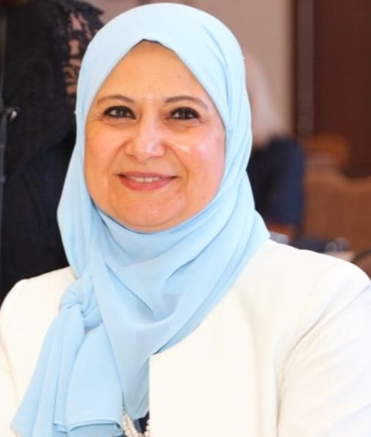

**Hala Mohamed Abou Yousef**

***Personal information***

**Name:** Hala Mohamed Abou Yousef

**Cellular**: +20-0122327660

**Address:** El Dokki-Giza

**E-mail**: [halaabouyousef1@yahoo.com](mailto:halaabouyousef1@yahoo.com)

***Academic Education:***

* ***B.Sc. Faculty of Science 1986***
* ***M. Sc Cairo University-Faculty of Science 1991***
* ***Ph. D Cairo University-Faculty of Science 2000***

***Positions Held and Current Position***

* 1995-2001: *Assistant* *Researcher* at *Central Agriculture Pesticide Laboratory-Agricultural Research Center.*
* 2001-2006: *Lecture of pesticide chemistry* at *Central Agriculture Pesticide Laboratory-Agricultural Research Center.*
* 2006 - 2011: *Associate pro. of pesticide chemistry* at *Central Agriculture Pesticide Laboratory-Agricultural Research Center.*
* 2011- till now: *Professor of pesticide chemistry* at *Central Agriculture Pesticide Laboratory-Agricultural Research Center.*

***Current position***:

*Head of Central Agriculture Pesticide Laboratory-Agricultural Research Center*