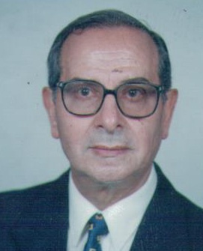Prof. Dr. Mounir D. Abdallah

**Position:** - Emeritus Professor, Department of Economic Entomology and Pesticides Faculty of Agriculture, Cairo University.

* Member in many Societies, Associations and Committees
* Contribution in many Scientific Reports and six books.
* Supervision of many M.Sc. and Ph.D. graduate Student.
* Ph.D. From the Agriculture University, Wageninger, Holland Oct. 1963.

**Title of thesis:** Interaction of some organophoshorus compounds in susceptible and resistant houseflies.

**List of publications:** more than 58 publications.

**Major Fields of interest:**

1. Biopesticides, particularly those including B. thuringiensis.
2. Resistamce against insecticides.
3. Physiological control, Particularly the use of juvenile hormone and mimics against some Lepidoperan pests.
4. Rodenicides and rodent control.
5. Integrated Pest Management.
6. Plant extractives.